Lab 1: Pressure Transducer Calibration

Sections:

* Introduction

1. **Introduction**

This is a report on the data collected in session one on Wednesday, January 24th that analyzes the pressure and current recorded from both the transducer and manometer while varying the flow velocity in the wind tunnel. Two sets of data were recorded, one while increasing flow velocity, and one while decreasing the flow velocity. Over the course of the report, these two sets of data will be compared and hereafter referred to as simply ‘increasing’ or ‘decreasing’.

* Current vs. Pressure plots and hysteresis analysis
  + Increased flow velocity and then decreased flow velocity
  + NEED TO TALK ABOUT THE MANOMETER PRESSURE CALCULATION AND DO THE EQUATION FORMAT and also need CONSTANTS AND GIVEN VARIABLES
  + The pressure vs. pressure graph slope close to one because calibrated correctly (not much deviation)
  + Show the calibration factors, supply the report with the slopes of the fit lines
  + No hysteresis? Maybe include a calculation using the source to show minimal hysteresis
    - Use the linear fit lines, find the horizontal midpoint of the lines, then the vertical midpoint between those two. Use the Current vs. Manometer graph for the hysteresis, as that is the same graph to show the calibration factors
    - Not much difference between the calibration factors (slopes) so the inaccuracy/hysteresis/difference in the pressures is most likely predominantly from human error
      * Talk about human error
        + Flipping the flow velocity switch (fan tilt)
        + Reading the manometer
  + Include the differences in pressure plot: shows that the decreasing manometer measurements were more accurate overall; also means there should be some hysteresis
  + ~~Also include the pressure vs. pressure plot original to compare with the current vs. pressure plot, as they have the same slope I believe? If not just use it to show the relationship to aid the difference in the pressures plot~~

1. **Manometer Pressure Calculation**

Manometer pressure values, were calculated in Pascals using equation (1), where *h* is the recorded height of the manometer, adjusted for the initial offset. The density of water used was 997.71 kg/m^3, while the gravitational constant used was 9.81 m/s^2.

$P_{manometer}= ρ_{water}gh$ (1)

1. **Analysis of Data for Hysteresis**

The calibration factors of the increasing (2) and decreasing (3) data sets are represented by the slope of the corresponding line of best fit in **Fig. 4**, which plots sensor current against manometer pressure.

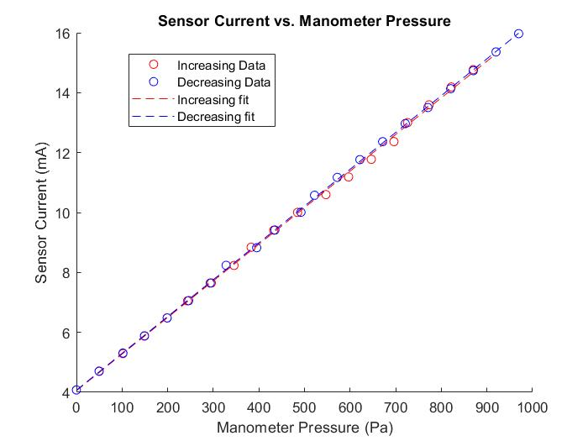

**Figure 4. Sensor Current vs. Manometer Pressure.** *Shows the linear regressions for both the increasing and decreasing data sets when plotting current against pressure. The slopes of the regression lines are the calibration factors, which, if close, mean that the system is well calibrated and there is little or no hysteresis.*

|  |  |  |
| --- | --- | --- |
|  | $$y = 0.0122*x + 4.0518$$ | (2) |
|  | $$y = 0.0123*x + 4.0695$$ | (3) |

These two slopes differ only by **0.816%,** as shown through the percent difference equation (4), indicating that if hysteresis is present, it is minimal. The slopes here are represented by variable *m*.

$^{3}Percent difference=\frac{{|m}_{increasing} -{ m}_{decreasing}|}{|\frac{m_{increasing} + m_{decreasing}}{2}|}$ (4)

**Fig. 1**, which plots transducer pressure readings against the manometer pressure readings,reinforces the idea that the data lacks hysteresis. The linear regression slopes should equal one in this case if the transducer data are identical to the manometer data, but as the data are not identical, the slopes as shown by equations (5) and (6) instead equal 0.9874 and 0.9933, for the increasing and decreasing sets, respectively. While these calibration factors are not exactly equal to one, they are extremely close, each being only a couple hundredths off, illustrating the negligibility of the data variation.

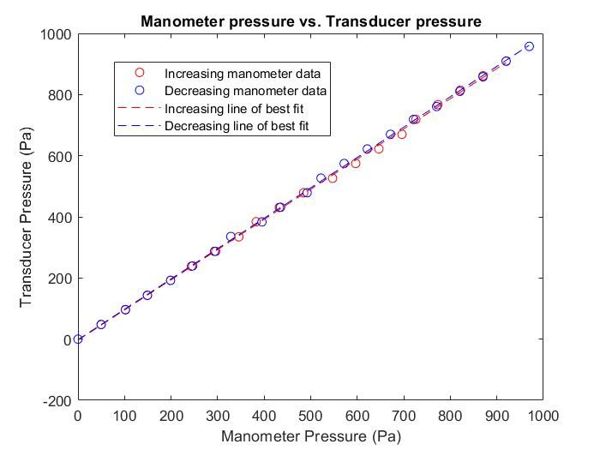

**Figure 1. Manometer Pressure vs. Transducer Pressure.** *Shows the linear regressions for both the increasing and decreasing data sets when plotting manometer pressure against transducer pressure. The slope of the linear lines should be equal to one if there is no discrepancy between the sets of data*

|  |  |  |
| --- | --- | --- |
|  | $$y = 0.9874*x – 3.3743$$ | (5) |
|  | $$y = 0.9933*x – 1.7110$$ | (6) |
|  |  |  |

To be thorough, if calculated using the lines of best fit for the calibration curves in **Fig. 4**, there is approximately only **0.567%** hysteresis for the entire data set. To calculate approximate hysteresis, the lines of best fit for the increasing and decreasing data sets were used as a basis. The midpoint between the first and last data point was found with the midpoint equation (7), and then the hysteresis was calculated with the hysteresis percentage equation (8).

|  |  |  |
| --- | --- | --- |
|  | $$^{4}x_{midpoint}=\frac{x_{max}-x_{min}}{2}+x_{min}$$ | (7) |
|  |  | (8) |

Where values were not the same between increasing and decreasing sets, the average of the two was used. The y-values for the upper and lower midpoints refer to the linear regressions, and as shown in **Fig. 4**, the upper regression corresponds to the decreasing data set. The x-value for the midpoint was used to calculate both midpoint y-values in junction with the linear regression equations (2) and (3). The values used for the calculations are as follows, with the x-values being pressure in Pascals, and the y-values being current in milliamps:

$$x_{max}= 919.8325 , y_{max}=15.36 , x_{min}=0 , y_{min}=4.0785$$

$y_{midpoint upper }=9.727, y_{midpoint lower}=9.663$

It should be noted that total hysteresis is typically calculated with two parallel lines, and in this case the lines of best fit are not parallel; however, the lines differ only slightly, so they were used for this approximate hysteresis calculation. With the variation in the calibration factors at a near-negligible level already, an estimation of hysteresis is suitable. Calculation shows that hysteresis is not present, as the percentage is small enough that other factors are likely the cause of the inconsistencies between the increasing and decreasing data sets.

1. **Sources of Error**

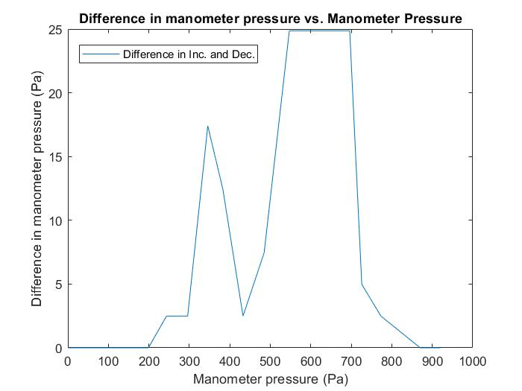

**Figure 3. Manometer Pressure Difference.** *Displays the total (absolute value) difference in manometer pressure plotted against manometer pressure to show the discrepancy between the increasing and decreasing data sets.*

Knowing the method of data collection involved reading from the manometer and adjusting propeller tilt, which both were not entirely exact, the low level of hysteresis can likely be attributed to human error and slight variations in flow. In **Fig. 3,** the difference in the manometer readings from increasing to decreasing can be seen to increase significantly at around the 600 Pascal mark. This difference does not take the transducer into account, and as it is only comparing the manometer readings, it shows that primarily the variation in the data occurred because of the human-recorded manometer data.

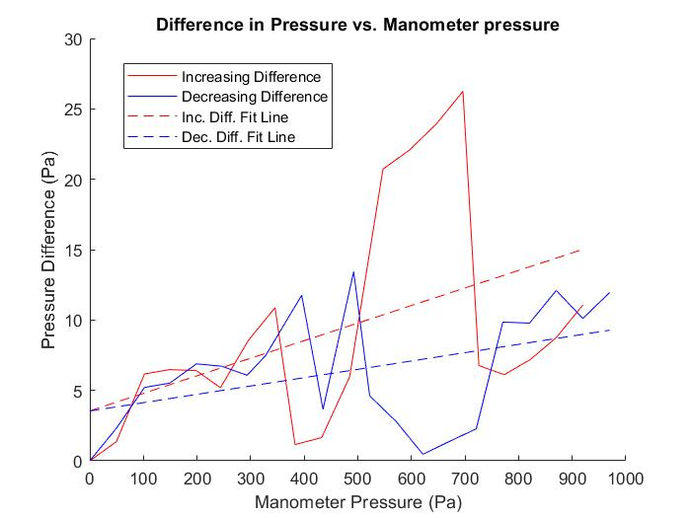

**Figure 2. Difference in Pressure vs. Manometer Pressure.** *Illustrates the total difference in manometer and transducer pressure plotted against manometer pressure. Compare with Fig. 3 to notice the similarities in primary areas of difference.*

**Fig. 2** also shows a difference in pressure reading, but instead compares the difference between the transducer and manometer readings. In combination, the figures portray that there was some inaccuracy in the transducer readings, but the inaccuracy can be mainly attributed to the manometer error, as the same spike in difference can be seen at around the 600 Pascal mark.

1. **Accuracy of Transducer Calibration**

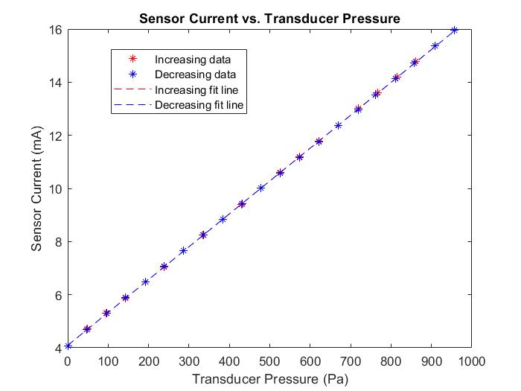

**Figure 5. Sensor Current vs. Transducer Pressure.** *Compares the two almost identical linear fits of the increasing and decreasing data recorded from the transducer, indicating correct calibration.*

Looking at the transducer readings alone, represented in **Fig. 5**, there is almost no distinction between the two lines of best fit, each having almost the same slope, which further indicates that the main source of error was in the manometer readings. Lack of distinction between the two calibration factors for the transducer data also indicates that the device is calibrated correctly, as it displays even less of a sign of hysteresis than that of the manometer data. The linear fit equations for the increasing and decreasing transducer data are represented by equations (9) and (10), in which the slopes are equal, and the intercept values differ by only two-thousandths.

|  |  |  |
| --- | --- | --- |
|  | $y = 0.0124*x + 4.0933$ | (9) |
|  | $$y = 0.0124*x + 4.0910$$ | (10) |

* ~~Current vs. Velocity plots to show what exactly? Shows the current increases at the second power when compared to flow velocity – need? Not sure.~~
* Extra credit: transducer sensor current vs transducer pressure readings
  + Shows calibrated correctly
  + Same slope, very slight difference in the y-intercepts for the linear fits
  + Provide the plot and explain it
  + Should show the hysteresis calculation?
* Conclusion
* Appendix – MATLAB Code: separate pdf combine?
* References: the hysteresis one and some online page and find another article, need one for the percent difference equation too

1. **References**

$^{1}$ Morris, K.A., “What is Hysteresis?,” Department of Applied Mathematics, University of Waterloo, Waterloo, Ontario, URL: https://uwaterloo.ca/applied-mathematics/sites/ca.applied-mathematics/files/uploads/files/morris_hysteresis_final.pdf

$^{2}$ Sethna, J.P., Kuntz, M., Dahmen, K., Perkovic, O., Kartha, S., Krumhansl, J.A., Roberts, B.W., Shore, J.D., “What’s Hysteresis?,” *Avalanches, Hysteresis and Noise*, Cornell University, Ithaca, New York, 1999, URL: http://www.lassp.cornell.edu/sethna/hysteresis/WhatIsHysteresis.html

$^{3}$ WebAssign, “Percent Error and Percent Difference,” 2013, URL: http://webassign.net/question_assets/ncsucalcphysmechl3/percent_error/manual.html

$^{4}$“Explanation of hysteresis calculation,” Missouri University of Science and Technology, Rolla, MO, Word Document URL: http://web.mst.edu/~cottrell/ME240/Resources/Calibration/Explanation%20of%20Hysteresis%20calculation.doc